Project: Visualizing Loan Data

Complete each section. When you are ready, save your file as a PDF document and submit it here: [https://classroom.udacity.com/nanodegrees/nd008/parts/c7cbb25d-deae-4be1-bc9c-71f465b849f8/project#](https://classroom.udacity.com/nanodegrees/nd008/parts/c7cbb25d-deae-4be1-bc9c-71f465b849f8/project)

# Step 1: Data Cleanup and Attribute Selection

I used the following columns in the data analysis:

Loan Status

State

Grade

Home Ownership

Date

Annual Income

DTI

Interest Rate

# Step 2: Tableau Visualizations

Please make sure you follow the [rubric](https://review.udacity.com/#!/rubrics/329/view) and include Tableau Dashboards, Stories, and the appropriate visualizations (small multiples, scatter plot, bar chart, etc..) your reviewer expects your visualizations to contain.

Attach your visualizations as Tableau Workbooks in a zip file along with this report.

**IMPORTANT**: Please save the workbooks as **Tableau Public** workbooks to allow reviewers to access your workbooks.

# Step 3: Questions

*Answer the following questions. Refer to your online visualizations to back up your answers.*

1. How do the attributes differ between borrowers who pay back their loans versus those who don't?

Borrowers who are likely to payback their loans are employed and own their home.

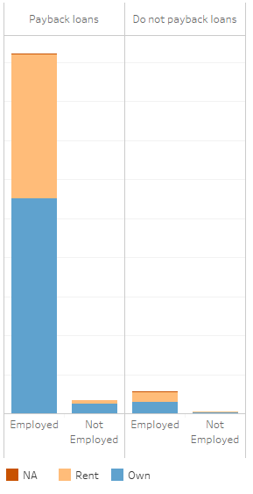

Based on averages, borrowers who do not payback their loans typically make less money. Their current DTI is higher.

Payback:



Do not payback:



Borrows who do not pay back their loans, show a slight increase in the amount they ask for when looking at the median requested amount.

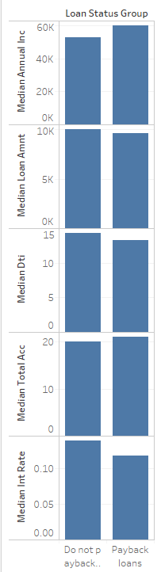

1. How do accepted and rejected loan data differ among different locations?

North Dakota has not accepted any loans. Maine has a smaller acceptance rate compared to other states. States of larger populations have larger rejection rates.

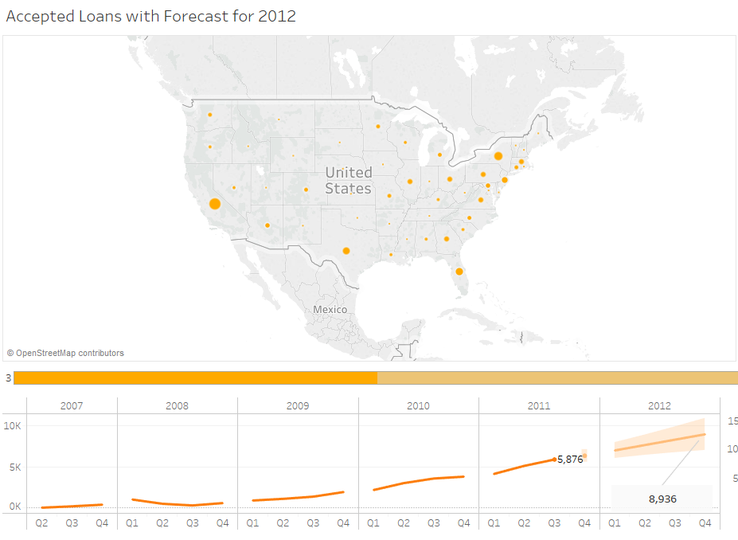

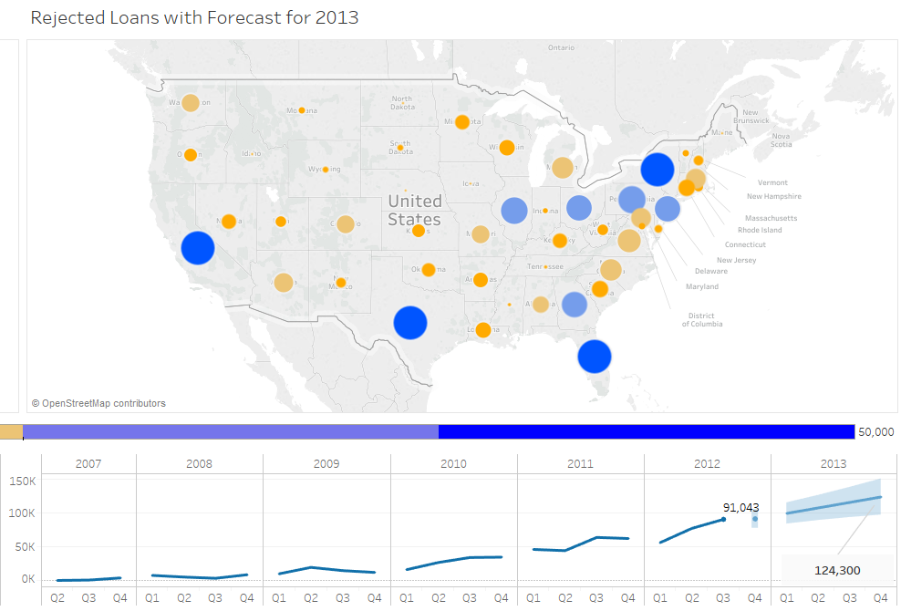

1. How have issued loans changed over time?

Only in the last two years of issued loans, have they been given to those who are not employed.

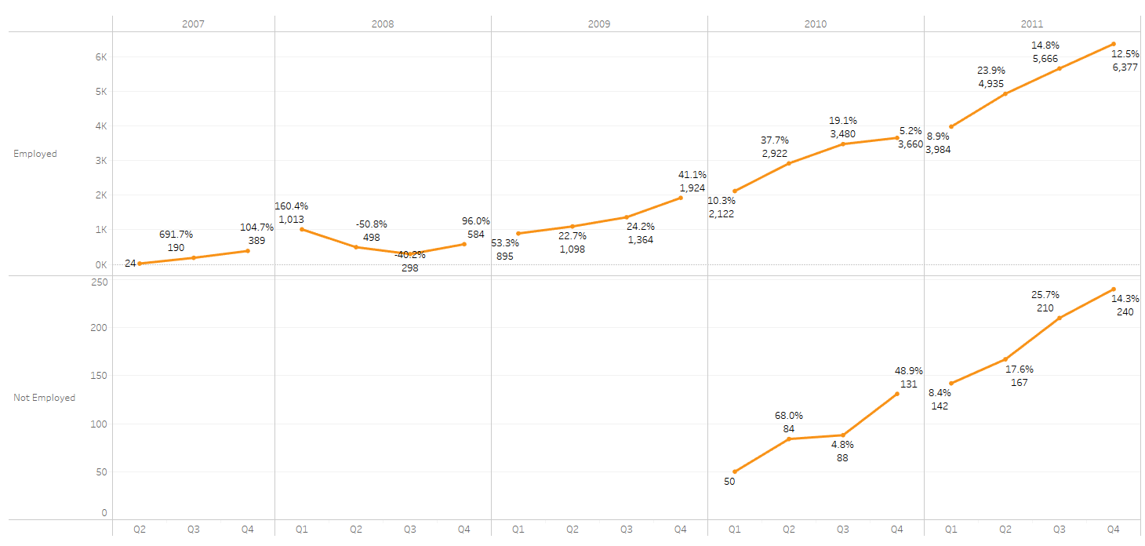

Most of the accepted loan growth comes from CA, TX, FL, East Coast and Midwestern states.

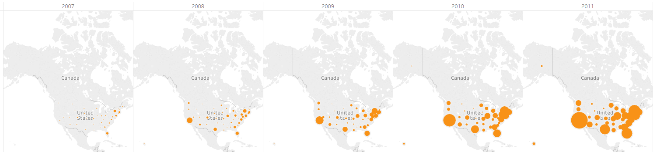

Over time, the total number of loans that have been requested has grown. Although, there is a dramatic decrease observed in May 2011. Accepted loans have maxed out around 2685 and stop in December of 2011. Whereas, rejected loans continue throughout 2012 and have grown to 39,429 at the peak of 2012.

Accepted

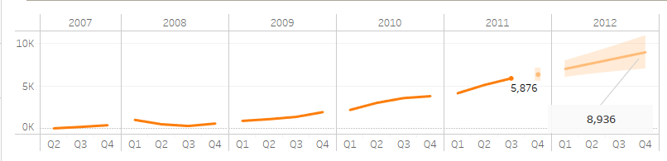

Rejected

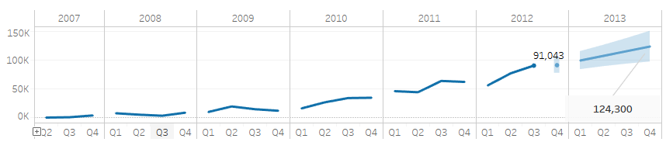

1. What is your additional question that you proposed? What is the answer? How did you come up with this question?

What amount and dti does the average rejected loan have.

Typically the rejected loan amount was about 12,000, with a risk score of 622.5, and a debt to income ratio of 1141.

